Information And Cyber Security
Unit : 3

Q. Explain SHA-1 in detail and explain how can mail security be achieved?
SHA-1 (Secure Hash Algorithm 1) creates a unique, fixed-size "fingerprint" (160-bit hash) from any data, used to check if files/messages changed (data integrity), but it's now broken and insecure. Mail security (confidentiality & integrity) is achieved with Encryption (scrambles message so only recipient reads) and Digital Signatures (using hashes like SHA-2/3 for sender verification & integrity), often via S/MIME or PGP, ensuring emails are private and authentic, not tampered with.
SHA-1 Explained Simply
- What it is: A mathematical recipe (hash function) that turns any message (text, file) into a short, unique code (hash or "message digest").
- Key Feature: A tiny change in the input gives a totally different hash (avalanche effect), making it good for checking for changes.
- How it Works (Simplified):
  - Pad & Prepare: Adds bits to make the message length divisible by 512 bits.
  - Chop into Blocks: Splits the message into 512-bit chunks.
  - Process Chunks: Uses complex math and bitwise operations (shifts, logical functions) on these chunks across 80 steps (four rounds of 20).
  - Combine & Output: Mixes results and outputs a final 160-bit hash.
- Problem: Attackers found ways (collision attacks) to create two different messages with the same SHA-1 hash, breaking its core promise of uniqueness.
- Status: Deprecated for most uses (like website SSL certificates) since around 2010-2016; strong successors are SHA-2 and SHA-3.
Achieving Mail Security
Securing email involves two main goals:
- Confidentiality: Keeping the content secret (Encryption).
- Integrity & Authentication: Ensuring it's from the right person and wasn't changed (Digital Signatures).
1. Encryption (Privacy):
- Symmetric: Same key to lock (encrypt) and unlock (decrypt). (Less common for general email).
- Asymmetric (Public/Private Keys):
  - You have a public key (share with everyone) and a private key (keep secret).
  - Sender uses recipient's public key to encrypt; only recipient's private key can decrypt.
  - Example: S/MIME or PGP uses this to scramble email content.
2. Digital Signatures (Authenticity & Integrity):
- Process (using SHA-2/3):
  - Sender hashes the email content (e.g., using SHA-256).
  - Sender encrypts this hash with their private key (this is the signature).
  - Email (original + signature) is sent.
  - Recipient receives email, decrypts the signature using sender's public key to get the original hash.
  - Recipient hashes the received email content themselves.
  - Compare: If the two hashes match, the email is authentic and unaltered.
In Simple Terms:
- Encryption: Like locking a letter in a special box only your friend can open.
- Digital Signature: Like a unique wax seal proving it's from you and hasn't been tampered with after sealing.
Modern Tools: PGP (Pretty Good Privacy) or S/MIME (Secure/Multipurpose Internet Mail Extensions) are common tools that combine these methods to secure your emails.
Q. What is Message Digest? Explain in detail MD5 algorithm. Applications of MD5
A Message Digest (like MD5) creates a unique, fixed-size "digital fingerprint" (128-bit for MD5) from any data, ensuring data integrity by detecting changes—even one bit alteration creates a totally different digest. The MD5 algorithm works by padding, dividing data into 512-bit blocks, and processing them through complex, repetitive rounds of bitwise operations, producing the digest. While historically used for digital signatures and file integrity checks, MD5 is now considered cryptographically broken due to vulnerabilities allowing collisions (different inputs, same hash), making it unsafe for critical security, but still useful for non-security tasks like file checksums.
What is a Message Digest?
A message digest is the output of a cryptographic hash function, acting as a unique, short summary or "fingerprint" of a larger piece of data.
- One-Way Function: Easy to create from data, but nearly impossible to reverse to get the original data.
- Fixed-Length: Always the same size, regardless of input data size (e.g., 128 bits for MD5).
- Sensitive to Changes: A tiny change in the input results in a completely different digest, proving data hasn't been tampered with.
The MD5 Algorithm in Detail (Simplified)
MD5 (Message-Digest Algorithm 5) processes data in a specific sequence.
- Padding: The original message is padded (extra bits added) so its length is just short of a multiple of 512 bits, with the original length appended at the end.
- Initialization: Four 32-bit variables (A, B, C, D) are set to initial fixed values.
- Processing (4 Rounds): The padded message is split into 512-bit chunks, and each chunk goes through four rounds of complex mathematical (bitwise AND, OR, XOR) and logical operations, using constants and the current variables.
- Output: The final values of A, B, C, D are combined to form the 128-bit (32-hex-digit) MD5 hash.
Applications of MD5 (Simple Terms)
- Data Integrity Checks (Checksums): Verify if a downloaded file (like an OS update or software) is corrupted or altered by comparing its MD5 hash to the original, ensuring it's identical.
- Password Storage (Historically): Storing the MD5 hash of a password instead of the password itself, so if a database is breached, attackers get hashes, not plain passwords.
- File Identification: Quickly identify large files by their unique hash.
Security Caveats
- Collisions Found: Researchers found ways to create two different files with the same MD5 hash, meaning attackers can forge digital signatures or malicious files that appear legitimate.
- No Longer Secure for Cryptography: Due to these vulnerabilities (collisions), MD5 is considered "cryptographically broken" and should not be used for sensitive security tasks like SSL certificates or secure digital signatures anymore; stronger algorithms like SHA-256 are recommended.

Q. Explain the steps for creating Digital Signature.
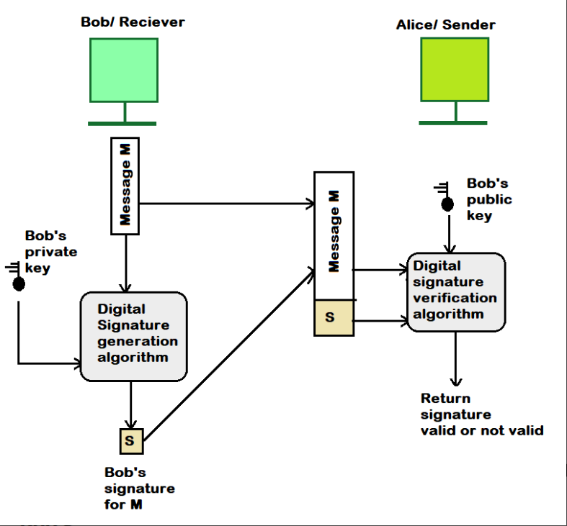
Creating a digital signature involves hashing your document to get a unique fingerprint, then encrypting that fingerprint with your private key to create the signature, which is sent with the document; the receiver uses your public key to decrypt the fingerprint and re-hashes the document themselves, comparing the two fingerprints to confirm the message's authenticity and integrity.

Steps for the Sender (Creating the Signature)
- Hash the Document (Create a Fingerprint): Take your document (message/file) and run it through a special one-way function (like SHA-256) to create a short, fixed-size string called a "hash" or "message digest" – think of it as a unique digital fingerprint.
- Encrypt the Hash (Sign): Take that hash and encrypt it using your private key (a secret key only you have). This encrypted hash is your digital signature.
- Send: Send the original document along with the digital signature to the recipient.
Steps for the Receiver (Verifying the Signature)
- Decrypt the Signature: Use the sender's public key (which is publicly available) to decrypt the digital signature, revealing the original hash the sender created.
- Hash the Received Document: The receiver independently runs the same hash function on the document they received.
- Compare: The receiver compares the hash they just calculated (Step 2) with the hash they decrypted from the signature (Step 1).
What Happens Next?
- If the hashes match: The signature is valid! It proves the document came from you (because only your private key could create that signature) and hasn't been tampered with (because the hash matches).
- If the hashes don't match: The signature is invalid. Either the sender isn't who they claim to be, or the document was altered after being signed.
Key Concepts
- Asymmetric Cryptography: Uses a pair of keys: a private key (secret) for signing and a public key (shared) for verification.
- Hashing: Creates a unique, fixed-length "fingerprint" (hash) of data, making it easy to detect any changes.
Q. Explain Chinese remainder theorem and its implication in cryptography
The Chinese Remainder Theorem (CRT) lets you solve one big math problem (finding a number) by breaking it into several smaller, easier problems using different remainders (like finding a number that leaves remainder 2 when divided by 3, 3 by 5, etc.). In cryptography, this is huge for efficiency: it speeds up massive calculations in RSA encryption by doing math on smaller numbers and combining results, and it helps secure keys by splitting them across systems so one breach doesn't compromise everything.
What it is (Simple Explanation)
Imagine you have a secret number, but you only know its remainders when divided by several small, coprime (no common factors) numbers.
- Problem: Find the number x.
- Given: x ≡ 2 (mod 3), x ≡ 3 (mod 5), x ≡ 2 (mod 7).
- CRT Says: There's one unique x (less than 357=105) that fits all these rules, and CRT tells you how to find it.
How it's used in Cyber Security (Implications)
- Speeding Up RSA: RSA decryption and signing involves huge numbers. CRT breaks these down into parallel calculations using the smaller prime factors of the large numbers (e.g., p and q), making them much faster.
- Secret Sharing & Key Security: You can split a secret key into shares, where each share is a remainder modulo a different small number.
- No single share reveals the key.
- You need a certain number of shares (e.g., 3 out of 5) to reconstruct the full key using CRT.
- This protects against attackers getting one piece of the puzzle; they need multiple parts across different systems.
- Error Correction: It helps systems detect and correct errors in data transmission by working with modular arithmetic.
In short, CRT turns complex, slow cryptography into manageable, faster pieces, while also providing ways to distribute and protect sensitive data.

Q. Explain RSA algorithm. Perform encryption and decryption using RSA algorithm for following values p=17, q=11, e=7, M=2
Q. Explain Diffie-Hellman with justification. Give the details of attack on Diffie Hellman algorithm.
Q. Explain Elliptic curve Arithmetic and Elliptic Curve cryptography in details.
Q. Explain the key steps involved in solving a system of modular congruences using the Chinese Remainder Theorem. How does the choice of pairwise coprime moduli contribute to its effectiveness?
Q. Discuss EL-Gamal arithmetic algorithm with example.

Unit : 4
Q. Illustrate with a neat diagram components of risk identification and risk assessment
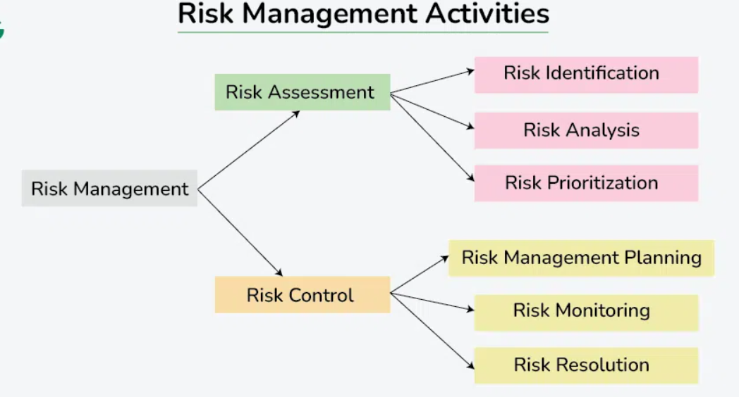
In information and cyber security, risk is a function of assets, threats, and vulnerabilities. The risk management process starts with risk identification and moves into risk assessment, which together help an organization understand its security posture.
1. Risk Identification
This is the foundational step, essentially answering the question: "What could go wrong?" It involves systematically uncovering and documenting potential sources of harm.
- Identify Assets: Create an inventory of everything of value that needs protecting. This includes hardware (servers, laptops), software, critical data (customer info, intellectual property), and even people and processes. The goal is to understand what is important and why.
- Identify Threats: Determine who or what might want to compromise those assets and how. Threats can be human (hackers, malicious insiders), environmental (natural disasters), or technical (equipment failure, software bugs).
- Identify Vulnerabilities: Pinpoint weaknesses in existing security controls or systems that a threat could exploit. Examples include weak passwords, unpatched software, or a lack of employee training.
2. Risk Assessment (Analysis & Evaluation)
Once risks are identified, the assessment phase evaluates their significance to determine which ones need the most attention. The core formula is generally: Risk = Likelihood × Impact.
- Analyze Likelihood: Estimate the probability of a specific threat exploiting a specific vulnerability. This involves considering threat motivation, capability, and the ease of exploitation.
- Analyze Impact: Determine the potential negative consequences if the risk materializes. Impacts can be financial loss, reputational damage, operational disruption, or legal penalties. This often uses scales (e.g., low, medium, high) to measure the severity of the harm.
- Calculate Risk Level: Combine the likelihood and impact ratings (often using a risk matrix) to arrive at an overall risk score.
- Prioritize Risks: Rank the identified risks from highest to lowest priority to focus resources on the most significant threats first.
The results of the risk assessment are typically documented in a risk register, which serves as a central record for ongoing management.
Q. Explain in detail Indian legal perpective on cybercrimes.
India's cybercrime legal framework primarily uses the Information Technology (IT) Act, 2000, supplemented by the Indian Penal Code (IPC) and the new Digital Personal Data Protection (DPDP) Act, 2023, to tackle crimes like hacking (Sec 66), data theft, phishing, online obscenity (Sec 67), and data interception (Sec 69). While the IT Act handles digital offenses, traditional IPC sections cover crimes like fraud or defamation committed digitally, with both laws working together (or sometimes separately) to prosecute offenders.
Key Laws Explained Simply
- Information Technology (IT) Act, 2000:
  - Purpose: Legalizes electronic transactions and records, and penalizes cybercrimes.
  - Key Sections:
    - Section 43A: Deals with compensation for failure to protect data.
    - Section 66: Hacking and unauthorized access (e.g., damaging systems).
    - Section 67: Publishing obscene content online (e.g., child pornography).
    - Section 69: Government power to intercept, monitor, or decrypt digital communication.
- Indian Penal Code (IPC), 1860:
  - Purpose: Covers traditional crimes like theft, cheating, and defamation, even if done using computers.
  - How it works: If a cybercrime involves classic offenses (like tricking someone for money), IPC sections (like cheating) can apply alongside the IT Act.
- Digital Personal Data Protection (DPDP) Act, 2023:
  - Purpose: A newer law focused specifically on protecting individuals' personal data, setting rules for how companies handle data and penalizing misuse.
How They Work Together
- Overlap: Many cybercrimes fit into both laws. A phishing scam (IT Act) that steals money (IPC Theft/Cheating) can be prosecuted under both.
- Dual Approach: The IT Act provides specific tools for digital offenses (data privacy, hacking), while the IPC handles the underlying criminal act (fraud, assault).
- Challenges: Sometimes, old laws struggle with new digital nuances (like online trolling) not clearly defined in the IT Act, leading to prosecution under IPC for defamation or intimidation instead.
Common Cybercrimes & Legal Coverage
- Hacking/Unauthorized Access: IT Act (Sec 66).
- Phishing/Fraud: IT Act (for digital aspects) + IPC (for cheating/theft).
- Cyberbullying/Harassment: IPC (defamation, criminal intimidation).
- Online Obscenity: IT Act (Sec 67).
- Data Breach: DPDP Act (for personal data), IT Act (for system damage).
In essence, India uses a layered legal system: the IT Act for the "how" (digital methods) and the IPC/DPDP Act for the "what" (the actual crime like theft or privacy violation).
Q. What are the types of Laws? Differentiate between Law and Ethics in information security.
Laws are mandatory rules from governments with penalties (fines, jail), while Ethics are moral guidelines (conscience, values) for "right" behavior, often voluntary but damaging to reputation if ignored in InfoSec, covering areas like Privacy, Cybercrime, E-commerce, and IP. In Cyber Security, Law (e.g., IT Act 2000) says what you must do (secure data), while Ethics (e.g., handling data responsibly) guides what you should do, preventing misuse even if legal, focusing on trust and societal good beyond legal compliance.
Types of Laws (General & Cyber)
- Constitutional Law: Rules from a country's constitution.
- Criminal Law: Deals with offenses against the state (theft, hacking).
- Civil Law: Disputes between individuals/organizations (contracts, damages).
- Cyber Laws:
  - Data Protection & Privacy Laws: GDPR, India's IT Act (protecting personal data).
  - Cybercrime Laws: Punishing hacking, data theft, fraud.
  - E-Commerce Laws: Regulating online transactions, digital signatures.
  - Intellectual Property (IP) Laws: Protecting digital content, software (Copyright).
Law vs. Ethics in Information Security (Simple Terms)
- Law: The Must-Do (Mandatory rules, enforced by police/courts, fines/prison).
- Ethics: The Should-Do (Moral compass, self-enforced by conscience, reputational damage).
Differentiation in InfoSec
- Legal Duty (Law): You must protect customer data under GDPR because it's the law, or face huge fines.
- Moral Duty (Ethics): Even if not illegal, it's unethical to snoop through employee emails for fun; it breaks trust.
- Enforcement: Breaking law = Legal penalty (jail/fine). Breaking ethics = Loss of trust, bad reputation, internal discipline.
- Scope: Law is uniform within a country; ethics can vary by company/professional standards.
- Example: Hacking (illegal). Sharing passwords with a friend (unethical, but might not be a specific law unless it breaches policy/contract).
In short, Law sets the minimum standard to avoid punishment; Ethics pushes for doing the right thing for people, even when not legally required, building trust in the digital world.
Q. List and explain any four commandments of computer ethics
The Ten Commandments of Computer Ethics provide a framework for responsible digital behavior, emphasizing non-harm (no data destruction/theft), respect for privacy (no snooping), integrity (no misinformation/plagiarism), legality (pay for software, get permission for resources), and social responsibility (consider impact, be respectful online) in cybersecurity, guiding users to protect data, systems, and others' digital rights.
The Commandments Explained in Cyber Security
- Do not use a computer to harm other people's data: Avoid malware, data deletion, or manipulation that damages others' digital assets.
- Do not interfere with other people's computer work: Don't sabotage systems or disrupt services (e.g., DDoS attacks, virus spreading).
- Do not snoop around in other people's computer files: Respect privacy by not accessing files, emails, or personal data without authorization (privacy).
- Do not use a computer to steal: This includes financial theft, identity theft, or stealing intellectual property.
- Do not use a computer to bear false witness: Don't spread lies, rumors, or misinformation online (fake news).
- Do not copy or use proprietary software for which you have not paid: Avoid software piracy; treat software as intellectual property.
- Do not use other people's computer resources without authorization or proper compensation: Don't hack into systems or use shared resources (like bandwidth) illegally.
- Do not appropriate other people's intellectual output: Don't plagiarize; give credit where it's due (intellectual property).
- Think about the social consequences of the program you are writing or the system you are designing: Consider potential misuse (e.g., creating addictive apps, biased AI).
- Always use a computer in ways that ensure consideration and respect for other humans: Practice digital etiquette (netiquette) and empathy in all online interactions.
Cyber Security Relevance
These commandments directly map to key cyber security principles:
- Data Protection: #1, #3, #4
- System Integrity: #2, #7
- Ethical Hacking/Security Testing: #3, #7 (understanding unauthorized access)
- Information Security: #5 (misinformation/disinformation)
- Legal Compliance: #6 (copyright)
- Responsible Innovation: #9 (security by design)
- Social Engineering/Human Factor: #10 (phishing, building trust).
Q. What is cybercrime and what are different types of cybercrimes explain in detail with examples?
Cybercrime involves illegal acts using computers/internet to steal data, disrupt systems, or commit fraud, impacting individuals, businesses, and governments, with types like phishing, malware/ransomware, identity theft, DDoS, and cyberstalking, all exploiting digital vulnerabilities for financial gain, revenge, or chaos.
What is Cybercrime?
Cybercrime is any criminal activity involving a computer, computer network, or digital device, either targeting the device itself or using it to facilitate other crimes, ranging from simple fraud to sophisticated data breaches.
Types of Cybercrimes Explained with Examples:
- Phishing & Social Engineering:
  - Explanation: Deceptive attempts (emails, texts, calls) to trick victims into revealing sensitive info (passwords, bank details) by impersonating legitimate entities.
  - Example: Receiving an email from a fake bank asking you to "verify your account" by clicking a link to a malicious site.
- Malware (Viruses, Worms, Trojans, Spyware):
  - Explanation: Malicious software designed to damage, disrupt, or gain unauthorized access to computer systems, steal data, or spy on users.
  - Example: A Trojan horse disguised as a free game download that installs spyware to log your keystrokes and steal passwords.
- Ransomware:
  - Explanation: A type of malware that encrypts a victim's files, demanding a ransom payment for the decryption key.
  - Example: A hospital's patient records get locked by ransomware; the attackers demand cryptocurrency to unlock them.
- Identity Theft & Financial Fraud:
  - Explanation: Stealing personal information (SSN, credit card numbers) to commit fraud, open accounts, or make unauthorized purchases.
  - Example: A hacker steals your credit card details from a data breach and uses them to buy electronics online.
- Hacking & Unauthorized Access:
  - Explanation: Gaining unauthorized entry into computer systems, networks, or accounts to steal data, disrupt services, or plant malware.
  - Example: An attacker exploits a software vulnerability to get into a company's server and steal customer data.
- Denial-of-Service (DoS/DDoS) Attacks:
  - Explanation: Overwhelming a target server or network with excessive traffic, making it unavailable to legitimate users.
  - Example: Flooding an e-commerce website with fake requests during a major sale, crashing it so real customers can't buy.
- Cyberstalking & Harassment:
  - Explanation: Using electronic means (social media, email, apps) to harass, threaten, or stalk someone, often involving repeated unwanted contact.
  - Example: An ex-partner repeatedly sending threatening messages and tracking your location through social media.
- Cyber Espionage:
  - Explanation: Secretly accessing sensitive government or corporate data for intelligence or competitive advantage.
  - Example: A foreign state actor hacking into a defense contractor's network to steal secret weapon designs.
- Child Pornography (CSAM):
  - Explanation: The illegal production, distribution, or possession of sexually explicit material involving children, facilitated by digital means.
  - Example: Illegally sharing CSAM files online through peer-to-peer networks.
Q. Explain Social engineering with example? Explain social effects of Cyber Stalking?
Social engineering manipulates people psychologically to get confidential info, like a scam email tricking you into clicking a link to install malware by faking a bank alert; cyberstalking's social effects include severe anxiety, reputation damage, isolation, and fear, eroding a victim's sense of safety and impacting relationships due to persistent harassment and threats online, making them feel constantly watched and vulnerable in their digital and real lives.
Social Engineering
Definition: The art of psychological manipulation to trick people into giving up confidential information or performing actions that compromise security, exploiting human trust rather than software flaws.
Example (Phishing):
- Reconnaissance: An attacker researches you on social media (LinkedIn, Facebook) to learn your employer, job role, and interests.
- Pretext: They send an email, pretending to be from your company's IT department, saying your account needs urgent verification due to a "security breach".
- Manipulation: The email uses a familiar logo and creates urgency ("Account will be suspended in 1 hour!"), asking you to click a link to "update" your password.
- Execution: You click the link, which leads to a fake login page (a clone of your company's portal). You enter your credentials, and the attacker steals them, gaining access to your company network and data.
Social Effects of Cyberstalking
Cyberstalking involves using digital communication (texts, social media, email) to harass, threaten, or embarrass someone, leading to profound social harm.
- Erosion of Trust & Isolation: Victims often withdraw socially, fearing who to trust online or offline, fearing that friends or acquaintances might be the stalker or believe the stalker's lies.
- Reputation Damage: Stalkers spread false rumors, embarrassing photos, or fake posts, ruining personal and professional reputations.
- Fear & Anxiety (Hypervigilance): Constant monitoring of devices and surroundings, feeling unsafe even at home, and an inability to relax.
- Social Exclusion: Friends and family may distance themselves, unsure how to help or fearing they'll become targets too, leaving the victim feeling alone.
- Public Humiliation: Malicious content can go viral, subjecting the victim to public shaming and ridicule from strangers, impacting their community standing.
- Psychological Trauma: Can lead to depression, PTSD, severe anxiety, and impacts on self-esteem, making it hard to form new relationships.
In essence, cyberstalking weaponizes the internet to make a victim's digital and physical world feel hostile and unsafe, destroying their peace and social connections.
Q. Outline the procedural steps involved in identifying and assessing risks as part of the information security risk management process?
Information security risk identification and assessment involve steps like defining scope, identifying critical assets, detecting threats & vulnerabilities, analyzing risk (likelihood/impact), evaluating/prioritizing risks using a matrix, and documenting findings for treatment, all aiming to protect confidentiality, integrity, & availability (CIA).
Procedural Steps for Risk Identification & Assessment
- Determine Scope & Context: Define what's being assessed (systems, data, processes) and set risk criteria (tolerance levels).
- Identify & Value Assets: List critical hardware, software, data, and services; determine their business importance.
- Identify Threats & Vulnerabilities: Find internal/external threats (hackers, malware, human error) and weaknesses (unpatched software, weak passwords).
- Analyze Existing Controls: Review current security measures (firewalls, policies) to see what's already protecting assets.
- Assess Risk (Likelihood & Impact): For each threat/vulnerability combo, determine:
  - Likelihood: How likely is the threat to exploit the vulnerability?
  - Impact: What would be the consequence (financial, reputational, operational) if it happened?
- Evaluate & Prioritize Risks: Use a risk matrix (High, Medium, Low) to rank risks by severity (Likelihood x Impact) and focus on the highest.
- Document Findings: Create a detailed risk register logging identified risks, their analysis, and current controls.
Key Concepts & Deliverables
- CIA Triad: Focuses on Confidentiality, Integrity, and Availability of information.
- Risk Register: A living document listing assets, threats, vulnerabilities, risks, impact, likelihood, and treatment plans.
- Risk Treatment Plan: Outlines how to address high-priority risks (avoid, mitigate, transfer, accept).

Q. Categorize the various types of laws, and provide a clear distinction between the concepts of law and ethics?
In information and cybersecurity, laws are formal, enforceable rules established by governments, while ethics are moral principles that guide behavior based on cultural or professional norms, without legal sanctions.
Categories of Laws in Information and Cybersecurity
Cyber law is not a single, distinct field, but an intersection of various legal fields that govern activities in cyberspace. Key categories include:
- Cybercrime Laws: These laws define and penalize criminal activities conducted using computers or targeting computer systems. Examples include hacking, identity theft, data theft, malware distribution, and cyber terrorism.
- Data Protection and Privacy Laws: These regulations govern how personal data is collected, processed, stored, and shared by organizations. They are designed to safeguard individuals' privacy and often include provisions for consent, data minimization, security safeguards, and breach notifications (e.g., GDPR in the EU, DPDP Act in India).
- Intellectual Property (IP) Laws: These laws protect original works, inventions, and brand names in the digital domain. They cover issues like software piracy, copyright infringement, trademark violations, and the protection of trade secrets online (e.g., the Digital Millennium Copyright Act (DMCA)).
- E-commerce and Digital Signature Laws: These provide a legal framework for electronic transactions, giving digital signatures and electronic records the same legal validity as their physical counterparts, which is crucial for secure online commerce.
- Sector-Specific Regulations: Certain critical sectors (e.g., banking, finance, healthcare, critical infrastructure) have specific cybersecurity standards and guidelines mandated by regulatory bodies (e.g., RBI guidelines for banks in India, HIPAA in the US).
- International Laws and Agreements: These include treaties and conventions (e.g., the Council of Europe Convention on Cybercrime) that aim to foster international cooperation in investigating and prosecuting cybercrimes and standardizing technology laws across borders.
Distinction Between Law and Ethics
Aspect | Law | Ethics
Source of Authority | Governmental bodies or legislative authorities. | Cultural norms, societal values, religious beliefs, or professional codes.
Enforcement & Sanctions | Mandatory compliance; enforced by courts and law enforcement, with penalties like fines or imprisonment for violations. | Voluntary compliance; relies on personal conscience, social pressure, and professional reputation. Violations may lead to social stigma or professional consequences, but not legal punishment.
Flexibility | Rigid and slow to change; requires formal legislative processes to adapt. | More flexible and can evolve more quickly with changing societal norms and individual judgments.
Scope | Focuses on establishing minimum standards of behavior necessary to maintain social order and justice. | Guides behavior beyond legal minimums, focusing on what is morally right and responsible, even if not legally required.
In cybersecurity, a key difference is that an action can be technically legal (e.g., using an office computer for personal use if not explicitly forbidden by policy) but considered unethical by professional standards. Ethical principles often inform and shape future laws, helping professionals navigate moral dilemmas in areas where laws have not yet been established.
Q. Explain with suitable example. i) Crimes against individuals ii) Crimes against organizations iii) Crimes against society
i) Crimes against individuals
These are illegal activities committed against a single person, typically aiming to cause personal harm, distress, or financial loss by exploiting their personal information or using digital platforms to harass them.
- Example: Identity Theft
  - A cybercriminal steals an individual's personal information, such as their Aadhaar card number, bank account details, or social security number, to impersonate them for financial gain, such as applying for loans or credit cards in the victim's name.
- Example: Cyberstalking/Harassment
  - An individual repeatedly receives threatening or unwanted messages, constant monitoring, or is defamed online through social media or email, causing emotional distress or fear for their safety.
ii) Crimes against organizations
These crimes target corporate networks, systems, and data to cause business disruption, financial loss, or to steal confidential information or intellectual property.
- Example: Denial of Service (DoS) Attack
  - Attackers flood an organization's website or network with excessive traffic, overwhelming its servers and causing it to slow down or crash entirely, making the services unavailable to legitimate users or customers.
- Example: Data Breach
  - A disgruntled employee or external hacker gains unauthorized access to a company's secure systems and steals sensitive data, such as customer records or internal trade secrets, which can then be sold or leaked, leading to significant financial and reputational damage.
iii) Crimes against society in information and cyber security
These are broad-scale crimes that affect the public at large, societal interests, or national security, often by using the internet to spread harmful material, facilitate illegal trade, or carry out acts of terror.
- Example: Cyber Terrorism
  - A terrorist group or individual launches an attack on a nation's critical infrastructure, such as the power grid, communication systems, or military networks, to cause widespread disruption, fear, or to achieve a political objective.
- Example: Distribution of Child Pornography/CSAM
  - Perpetrators use the internet to produce, distribute, or access child sexual abuse material (CSAM), an act which causes immense harm to children and pollutes the societal environment.
Q. Define cyber-crime. Explain any three categories of cyber-crime.
Cybercrime involves illegal acts using computers/networks, targeting individuals, property, or organizations for financial gain or disruption, with key categories like Malware & Ransomware (infecting systems for data theft/control), Phishing & Social Engineering (tricking users for info), and Identity Theft & Fraud (stealing personal data for financial crimes) being prevalent threats in information security.
What is Cybercrime?
Cybercrime is any criminal activity that uses a computer, computer network, or networked device as its target or means to commit an illegal act, ranging from simple online scams to large-scale data breaches, impacting individuals, businesses, and governments globally.
Three Categories of Cybercrime
- Malware Attacks (Viruses, Ransomware, Spyware):
  - Description: Malicious software designed to infiltrate systems, disrupt operations, steal data, or hold it hostage. Ransomware encrypts files and demands payment for their release, while viruses, worms, and spyware steal info or damage systems.
  - Impact: Data loss, system downtime, financial theft, and significant operational disruption for organizations.
- Phishing & Social Engineering:
  - Description: Using deceptive tactics (emails, messages) to trick victims into revealing sensitive information (passwords, credit cards) or downloading malware, often by impersonating legitimate entities.
  - Impact: Compromised accounts, unauthorized access, financial fraud, and identity theft, affecting both individuals and large organizations.
- Identity Theft & Online Fraud:
  - Description: Stealing personal identification information (PII) to impersonate someone for financial gain (e.g., opening accounts, making purchases) or committing various scams like advance-fee fraud or investment scams.
  - Impact: Severe financial damage, ruined credit, emotional distress for victims, and significant losses for businesses.
Q. Explain risk identification, risk Assessment, risk control strategies.
In cybersecurity, risk management involves identification (finding assets, threats, vulnerabilities), assessment (analyzing likelihood and impact to prioritize risks), and control (applying strategies like avoid, mitigate, transfer, accept) to protect information systems, forming a cycle of continuous improvement. It's about proactively managing threats like malware or phishing, weaknesses like outdated software, and ensuring business continuity.
1. Risk Identification
This is the process of finding what needs protection and what could harm it.
- Identify Assets: Inventory crucial elements (data, hardware, software, people).
- Identify Threats: List potential dangers (hackers, malware, insider threats, natural disasters).
- Identify Vulnerabilities: Find weaknesses (unpatched software, weak passwords, unsecured networks).
- Link them (A+T+V=R): A risk is the intersection of an Asset, a Threat, and a Vulnerability.
2. Risk Assessment
This step analyzes the identified risks to understand their severity.
- Analyze Likelihood: How probable is it that a threat exploits a vulnerability?
- Analyze Impact: What damage (financial, operational, reputational) would occur if it happened?
- Prioritize Risks: Rank risks from high to low based on likelihood and impact, focusing on critical ones first.
3. Risk Control Strategies (Risk Treatment)
These are actions taken to manage prioritized risks, often summarized as the 4 T's:
- Avoid (Eliminate): Stop the activity causing the risk (e.g., deactivating unused ports).
- Mitigate (Reduce): Implement controls to lower likelihood or impact (e.g., encryption, training, patching).
- Transfer (Share): Shift risk to a third party (e.g., cyber insurance).
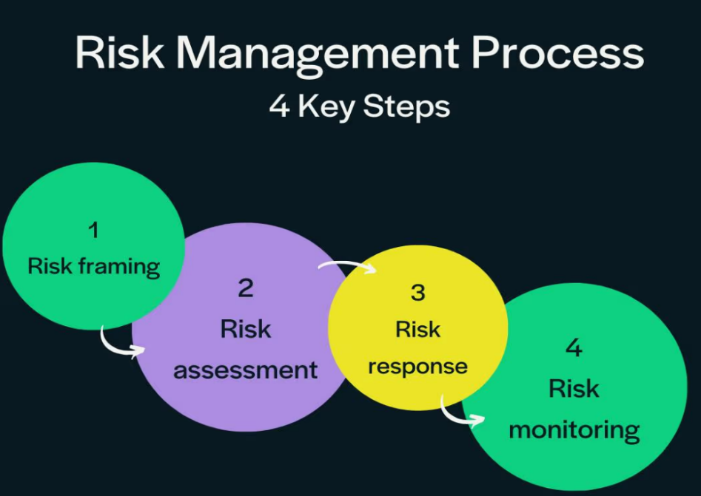
- Accept (Retain): Acknowledge the risk and its potential cost if it's low and treatment is expensive.
The Cycle:
These stages aren't one-time; they're part of a continuous cycle including Reviewing controls and adapting to new threats, ensuring ongoing security posture.
Q. Explain the Laws and Ethics in Information Security.
In InfoSec, Laws are mandatory rules (like data breach notification, privacy acts) with penalties, while Ethics are moral principles guiding responsible conduct (privacy, integrity, accountability) beyond legal minimums, crucial for trust, with professionals needing both compliance and ethical judgment to prevent harm, build trust, and avoid legal issues in the digital world. Laws define what you must do, while ethics guide what you should do, making them complementary for secure, responsible tech use.
Information Security Laws (Mandatory Rules)
Laws provide legal frameworks to punish cybercrimes and protect data, with consequences like fines or jail.
- Data Protection Laws: GDPR, CCPA, India's IT Act (Sections 43, 66) mandate how personal data is handled, requiring consent and breach notification.
- Cybercrime Laws: Define offenses like hacking, data theft, virus distribution, and tampering with computer source code, with specified punishments.
- Privacy Laws: Govern electronic communications (like ECPA in the US) and data privacy.
- Intellectual Property (IP) Laws: Protect software, patents, trademarks from unauthorized use.
Information Security Ethics (Moral Conduct)
Ethics are principles guiding moral choices, fostering trust and professional standards beyond what laws require.
- Confidentiality & Privacy: Protecting sensitive data from unauthorized access.
- Integrity: Ensuring data is accurate and unaltered.
- Accountability: Taking responsibility for actions, reporting breaches, being transparent.
- Professionalism: Maintaining competence, acting within authorized boundaries, promoting awareness.
- Fairness & Societal Impact: Considering broader effects of tech, ensuring access, avoiding bias.
Why They Matter Together
- Laws set minimums; ethics aim higher: Laws cover what (don't hack), ethics cover how (responsible access, care).
- Legal Liability: Non-compliance leads to fines; unethical behavior can also create liability, even if technically legal.
- Trust & Reputation: Ethical practices build user trust, vital for digital business.
- Policy as "Internal Law": Security policies enforce ethical and legal compliance within organizations, acting as internal laws.
In essence, information security professionals use laws as a baseline and ethics as a guide to create a secure, trustworthy digital world.
Q. Differentiate between quantitative and qualitative risk.
In cybersecurity, Qualitative Risk uses subjective terms (High, Medium, Low) based on expert judgment for quick prioritization, while Quantitative Risk uses objective numbers ($, %, #) derived from data for precise financial impact analysis, helping decide resource allocation by answering "how much" vs. "how bad". Qualitative is fast but subjective, ideal for initial assessment; Quantitative is detailed, data-driven, but complex, best for critical systems needing monetary justification.
Qualitative Risk Assessment
- Focus: Subjective evaluation of risk quality.
- Method: Expert opinions, experience, risk matrices (e.g., 3x3, 5x5).
- Output: Risk levels (High, Medium, Low), categories, or scores.
- Pros: Quick, easy, requires fewer resources, good for emerging threats.
- Cons: Subjective, potentially biased, lacks precision, harder to compare risk accumulation.
- Example: A breach is "High" likelihood because of past incidents, with "High" impact (reputation, trust).
Quantitative Risk Assessment
- Focus: Objective, numerical measurement of risk.
- Method: Statistical models, historical data, financial metrics.
- Output: Monetary values (Annual Loss Expectancy - ALE), probabilities (%), downtime.
- Pros: Objective, data-driven, precise, justifies security investments in financial terms.
- Cons: Time-consuming, complex, requires significant data and resources, expensive.
- Example: A data breach costs us an estimated $500,000 annually (ALE) with a 20% chance of occurring.
Key Differences Summarized
Feature | Qualitative | Quantitative
Basis | Judgment, experience, descriptions | Data, metrics, statistics
Output | High/Medium/Low, Scores | $, %, Numbers
Precision | Low (Subjective) | High (Objective)
Speed | Fast | Slow, Complex
Use Case | Initial triage, complex/new risks | Detailed analysis, ROI justification

Q. Discuss any four types of cyber attacks.
Four major cyberattacks in information security include Malware (harmful software like viruses/ransomware), Phishing (deceptive attempts to steal info), Denial-of-Service (DoS) (overwhelming systems with traffic), and SQL Injection (exploiting database vulnerabilities), all aiming to steal data, disrupt services, or gain unauthorized access, with attackers using social engineering, code exploits, and network flooding.
Here's a breakdown of these four common cyberattacks:
- Malware Attacks: This broad category includes malicious software designed to harm systems, steal data, or gain unauthorized access.
  - Examples: Viruses, worms, spyware, trojans, and ransomware, which encrypts files for ransom.
  - Impact: Data theft, system damage, financial loss, or complete system takeover.
- Phishing: Attackers use deceptive emails, messages, or websites to trick users into revealing sensitive information like passwords, credit card numbers, or bank details.
  - Method: Often uses social engineering, impersonating trusted entities (banks, companies).
  - Impact: Credential theft, financial fraud, and account compromise.
- Denial-of-Service (DoS/DDoS): The goal is to make a network or online service unavailable to legitimate users by flooding it with overwhelming traffic.
  - DDoS (Distributed DoS) uses a network of compromised devices (botnet) for massive traffic, making it harder to stop.
  - Impact: Service disruption, downtime, and revenue loss for businesses.
- SQL Injection (SQLi): Attackers insert malicious SQL code into web forms or input fields to manipulate a website's database.
  - Method: Exploits vulnerabilities in web application databases.
  - Impact: Stealing, modifying, or deleting database records, gaining admin access, and data breaches.
These attacks highlight different vectors—software (malware), human manipulation (phishing), network saturation (DoS/DDoS), and code exploitation (SQLi)—showing the diverse threats facing digital systems.
Q.Define cyber crime. Explain any four categories of cyber crime.
Cybercrime involves illegal acts using computers/internet for financial gain or disruption, categorized by target, including Individual (phishing, stalking), Organizational (ransomware, data breaches), Property (fraud, IP theft), and Societal/Government (cyberterrorism, espionage) crimes, all exploiting digital vulnerabilities for harm.
Definition of Cybercrime
Cybercrime is any criminal activity that targets or uses a computer, network, or networked device, often involving financial fraud, data theft, disruption, or harassment, impacting individuals, businesses, and governments globally.
Four Categories of Cybercrime
- Individual Cybercrimes: Focus on harming people directly, using digital means for harassment or theft from individuals.
  - Examples: Cyberstalking, bullying, identity theft, phishing scams targeting personal info, spreading malicious content.
- Organizational Cybercrimes: Aim at businesses and corporations, stealing data or disrupting operations for profit.
  - Examples: Ransomware attacks, large-scale data breaches, intellectual property theft, Denial of Service (DoS) attacks.
- Property Cybercrimes: Target digital assets, financial systems, or intellectual property for monetary gain.
  - Examples: Credit card fraud, online banking scams, theft of confidential web data, illegal distribution of copyrighted material.
- Societal/Government Cybercrimes: Involve terrorism, espionage, or attacks on critical infrastructure, aiming for large-scale societal disruption.
  - Examples: Cyberterrorism, hacking government systems, espionage, attacks on power grids or communication networks.
Q. What are the objectives and pros and cons of Quantitative and Qualitative risk Assessment?
In information and cybersecurity, qualitative risk assessment quickly identifies and prioritizes risks based on expert judgment, while quantitative risk assessment provides detailed, objective, financial analysis using data and statistical models.
Qualitative Risk Assessment
Objectives:
- To quickly and cost-effectively identify major risks and vulnerabilities within an organization's systems and processes.
- To prioritize risks (e.g., as High, Medium, or Low) using subjective, descriptive scales to determine which require immediate attention.
- To raise security awareness among staff and facilitate communication about general risk areas across different teams.
- To provide an initial, high-level understanding of the risk landscape, especially when historical data is scarce or the organization is new to risk management.
Pros:
- Speed and simplicity: It is fast and easy to implement and does not require complex tools or extensive training.
- Flexibility: It can be used to assess a wide range of risks, including emerging threats or those with limited data, and can incorporate valuable human insights and experience.
- Cost-effective: It is generally inexpensive to perform, often using simple methods like risk matrices or brainstorming sessions.
Cons:
- Subjectivity and bias: Results heavily depend on the assessor's experience and perception, which can lead to inconsistencies and personal bias.
- Lack of precision: It uses general categories, making it difficult to perform a detailed cost-benefit analysis for specific controls or to measure risk reduction over time.
- Prioritization challenges: It can be difficult to decide which risks to address first if multiple items fall into the same "high" or "red" category.
Quantitative Risk Assessment
Objectives:
- To provide an objective, data-driven, and detailed understanding of risk exposure in measurable, often monetary, terms.
- To enable cost-benefit analysis for proposed security controls, helping justify security investments and allocate resources efficiently.
- To support informed decision-making by offering clear, precise, and repeatable results based on facts and statistical models.
- To communicate risk exposure to top management and the board in "business language" (i.e., dollars and cents).
Pros:
- Objectivity and precision: It uses data, metrics, and mathematical models to provide accurate, defensible, and repeatable results, minimizing personal bias.
- Actionable insights: By assigning financial values (like Annual Loss Expectancy or ALE), it provides a clear basis for prioritizing risks and demonstrating the ROI of mitigation strategies.
- Enhanced communication: Expressing risk in monetary terms facilitates clear and unambiguous communication with stakeholders, investors, and management.
Cons:
- Time- and resource-intensive: It is a complex process that requires significant time, advanced tools, and specialized expertise.
- Data dependency: Its accuracy is highly dependent on the availability of reliable, historical data, which can be difficult or expensive to collect.
- Complexity: The use of complex models (e.g., Monte Carlo simulations) can make the results difficult to understand or interpret without statistical knowledge.
Many organizations adopt a hybrid approach, using qualitative assessments for an initial, broad overview and then applying quantitative analysis to the highest-priority risks that require detailed financial scrutiny.
Q. Describe different categories of cybercrime with example.
Cybercrime falls into categories like Financial Fraud (phishing, banking scams), Data Theft/Breaches (identity theft, corporate espionage), Malware Attacks (ransomware, viruses, trojans), Attacks on Systems/Availability (DDoS, hacking), Harassment/Social Crimes (cyberbullying, stalking, defamation), and Illegal Content/Terrorism (child exploitation, cyber terrorism). Examples include receiving a fake bank email (phishing) to steal login details, a ransomware attack encrypting files for a ransom, or a state actor stealing national secrets.
Categories & Examples of Cybercrime
- Financial & E-commerce Fraud
- Description: Deceiving individuals or businesses for monetary gain.
- Examples: Phishing emails asking for bank details, fake online stores, credit card theft, investment scams.
- Identity Theft & Data Breaches
- Description: Stealing personal data (SSNs, passwords) to impersonate or commit fraud.
- Examples: Using stolen info for fraudulent credit accounts, data breaches exposing customer records, selling stolen data on the dark web.
- Malware Attacks
  - Description: Malicious software designed to disrupt, damage, or gain unauthorized access.
  - Examples:
    - Ransomware: Encrypts files, demands ransom for decryption key.
    - Viruses/Worms: Spread to corrupt files or infect networks.
    - Trojans: Disguised as legitimate software to create backdoors.
- Attacks on Systems & Availability
  - Description: Disrupting or taking control of computer systems and networks.
  - Examples:
    - DDoS Attacks: Overwhelming servers with traffic to crash websites.
    - Hacking/Unauthorized Access: Gaining entry to systems without permission.
- Cyber Harassment & Social Crimes
  - Description: Using digital platforms to bully, stalk, or defame individuals.
  - Examples: Cyberbullying, online stalking, spreading false information (defamation), creating fake profiles to deceive.
- Cyber Espionage & Terrorism
  - Description: State-sponsored or politically motivated attacks to steal secrets or disrupt critical infrastructure.
  - Examples: Governments hacking foreign agencies for classified data, cyberattacks on power grids, spreading propaganda.
- Intellectual Property Theft
  - Description: Illegal use or distribution of copyrighted material, patents, or trademarks.
  - Examples: Software piracy, unauthorized sharing of movies/music, stealing trade secrets
The major categories of cybercrimes are:
- Attacks on individuals: identity theft, cyberstalking, or credit card fraud
- Attacks on property: DDoS attacks, installing viruses on computers, or copyright infringement
- Attacks on government: hacking, cyber terrorism, or spreading propaganda

